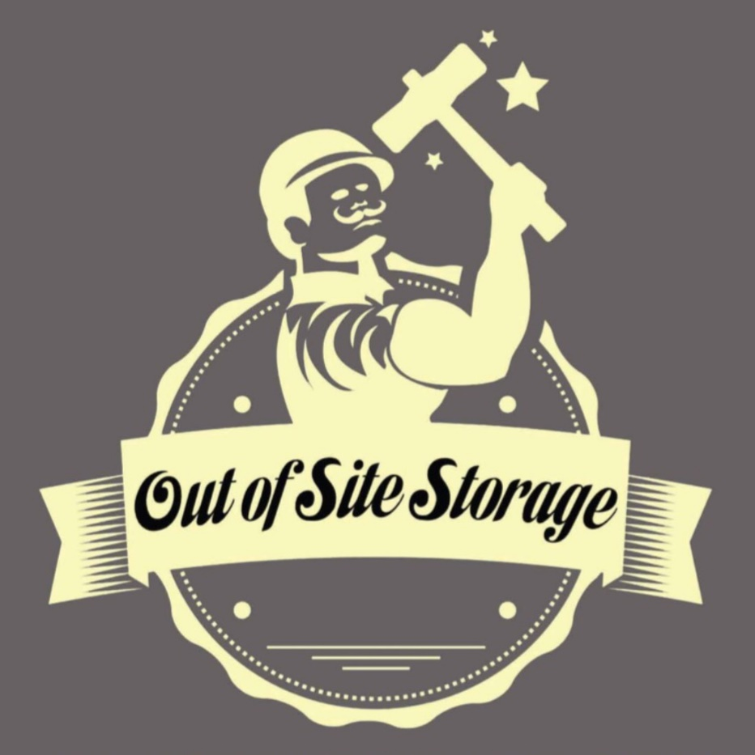

SOLD OUT!!
We are currently sold out of available storage units – as people do move in and out – there are often openings that
come available.

If you would like to be on a waiting list, please call Debbie at 503-791-8330

